AeroServe Software Testing Report (Revised)
Test ID | Test Case Description | Expected Outcome | Actual Output | Result | Screenshot
TC-001 | Valid User Login. POST to /api/auth/login. Returns JWT & navigates to Dashboard. | JWT generated, successful redirect to Dashboard. | As Expected | Pass | 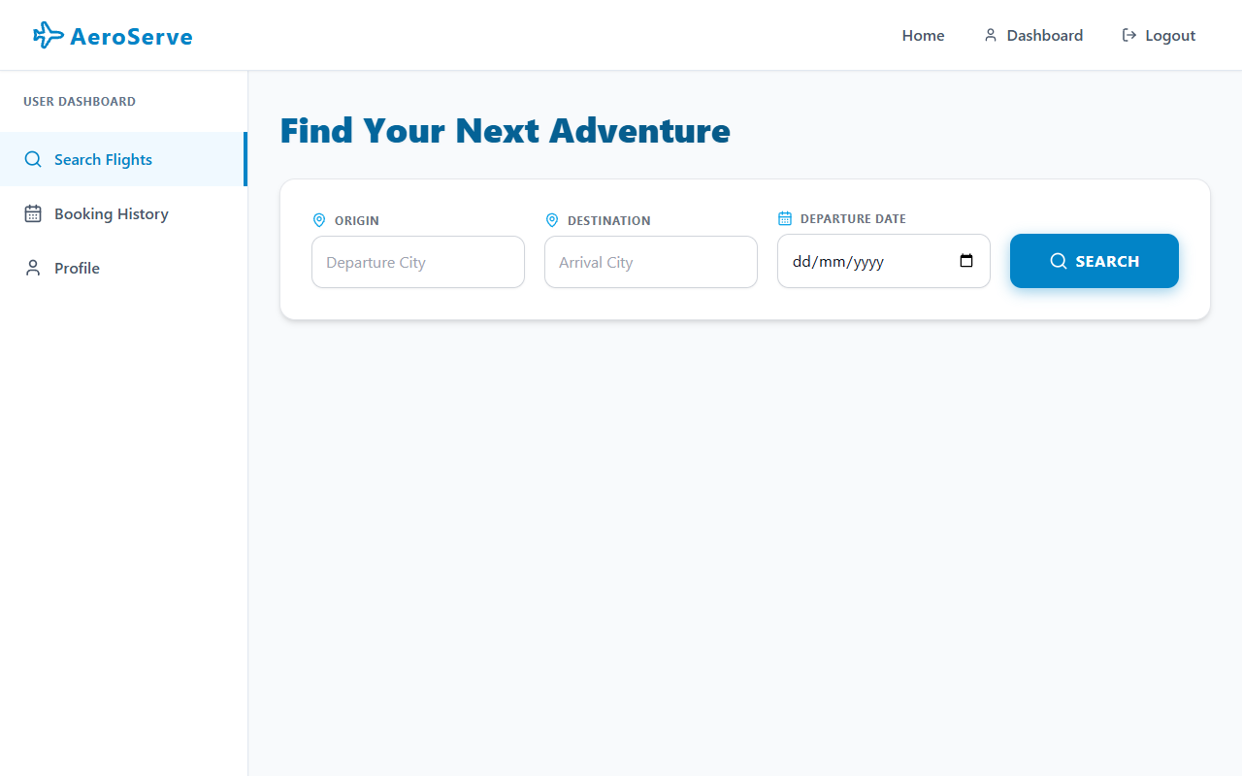
TC-002 | Invalid Credentials. Submitting incorrect email/password. | Returns 401 Invalid email or password. UI displays red error banner. | As Expected | Pass | 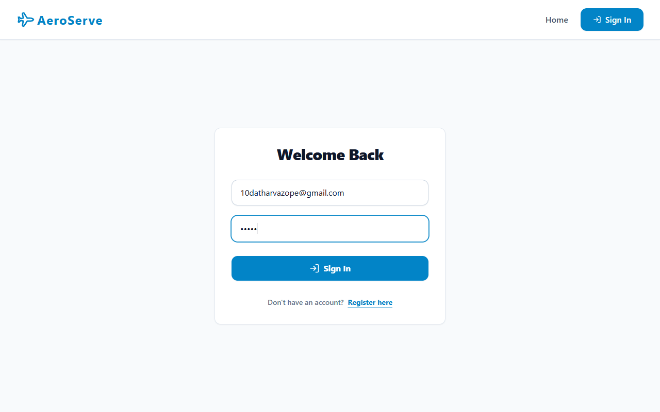
TC-003 | Access Protected Route (No Token). | Accessing endpoints without JWT returns 401 Not authorized, no token. | As Expected | Pass
TC-004 | Valid Flight Search. Entering valid source/destination/date. | Returns array of flights. UI dynamically renders flight cards. | As Expected | Pass
TC-005 | Booking Validation: Missing Seat. | Returns 400 A seat must be selected for every passenger. | As Expected | Pass | 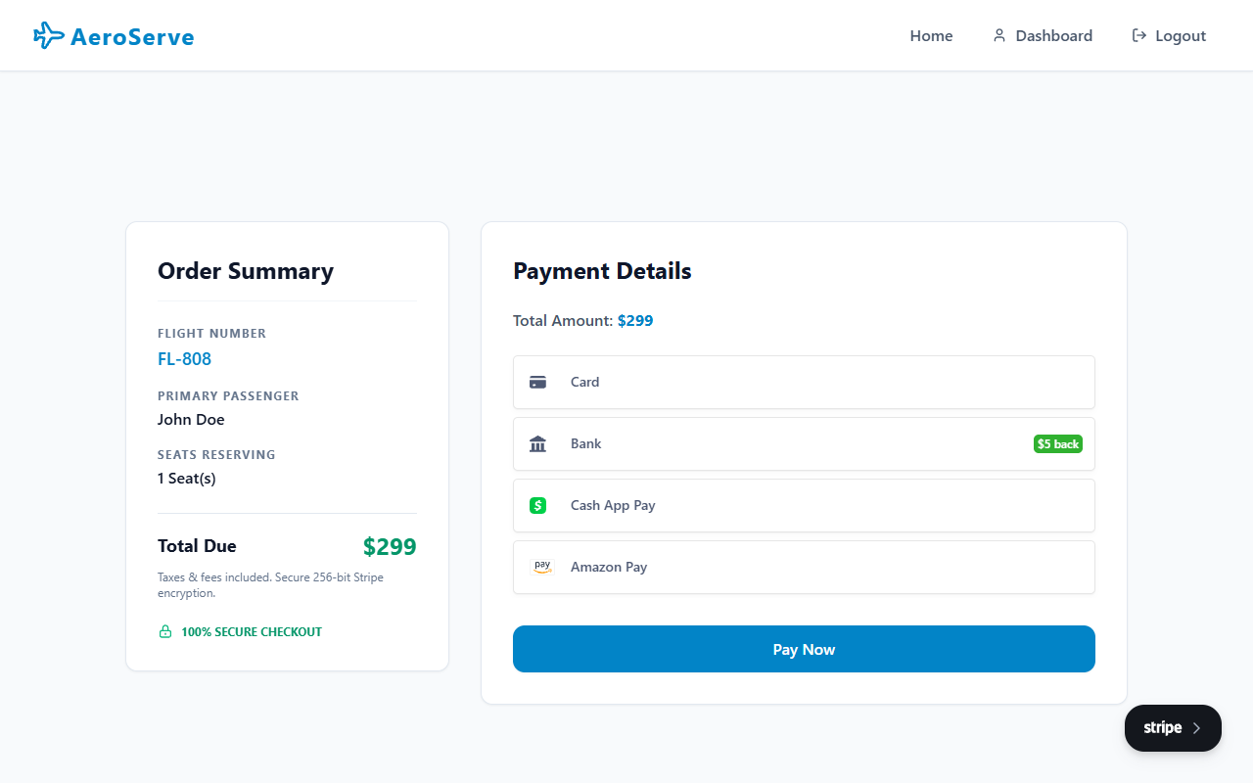
TC-006 | Stripe Payment: Success & Boarding Pass Rendering. | Completes Stripe intent, saves reservation to DB, renders dynamic Boarding Pass QR. | As Expected | Pass | 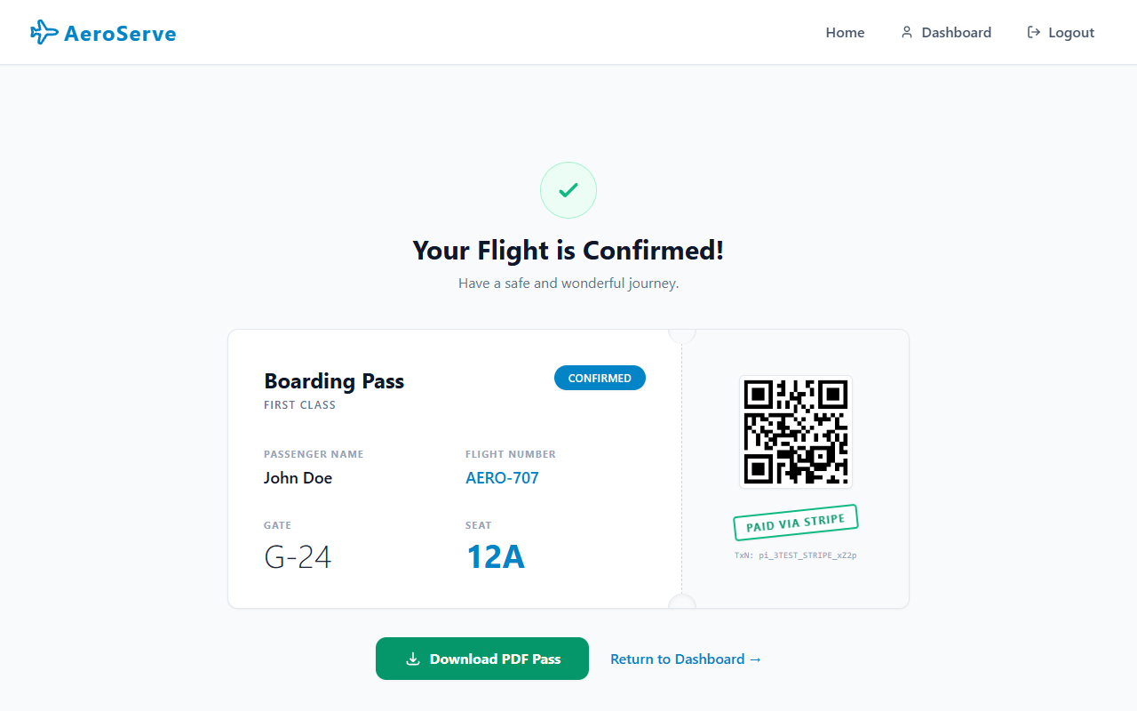
TC-007 | Stripe Payment: Empty Fields Validation. | Inline Stripe validation blocks API call. Highlights fields in red. | As Expected | Pass
TC-008 | Cancellation: Tier 1 (> 48 hrs). | Calculates exactly 90% refund. DB updates status to 'Cancelled'. | As Expected | Pass | 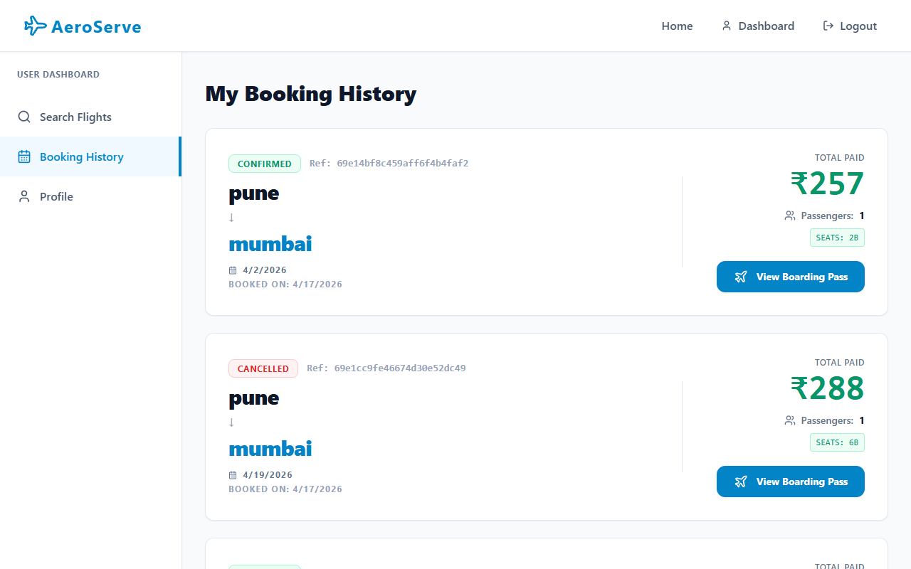
TC-009 | Cancellation: Tier 3 (< 24 hrs). | Calculates 0% refund. Seat is still released to inventory. | As Expected | Pass
TC-010 | Cancellation: Past Departure. | Returns 400 Cannot cancel — this flight has already departed. | As Expected | Pass
TC-011 | Admin Reports Dashboard. | Accurately calculates total bookings, flights, users, and overall revenue. | As Expected | Pass | 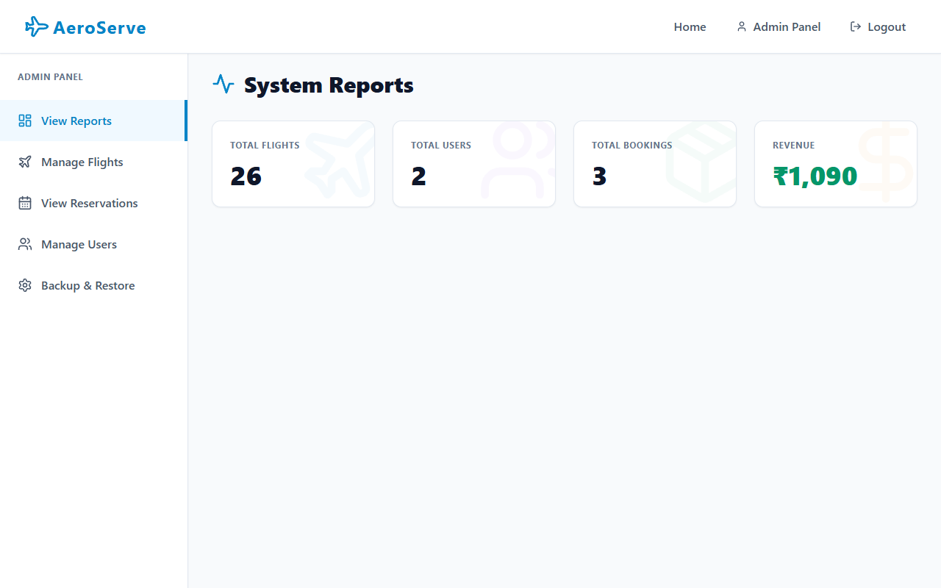
TC-012 | Admin Flight Management. | Admin can add, edit, or delete flights. Seat counts dynamically adjust. | As Expected | Pass | 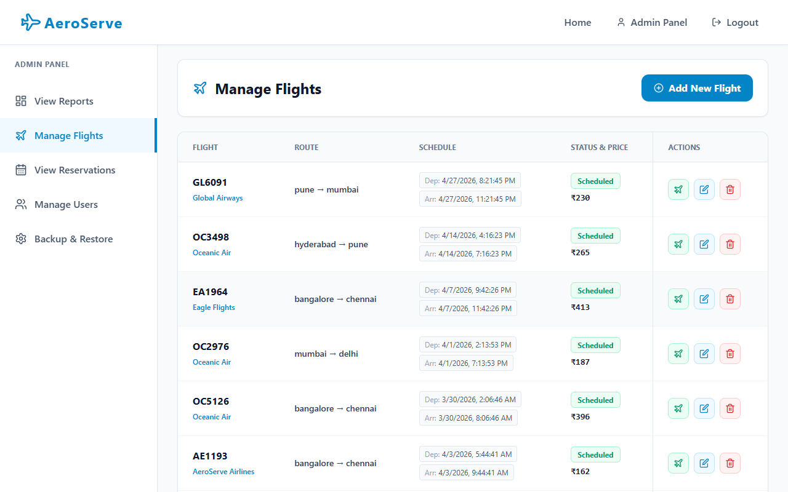
TC-013 | Admin User Management. | Admin can view all users, update roles, or delete users from the system. | As Expected | Pass | 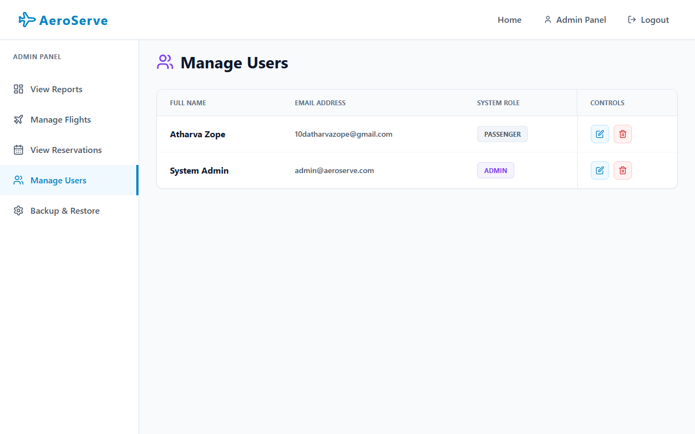
TC-014 | Admin Reservations Ledger. | Presents a global read-only view of all reservations without cancel buttons. | As Expected | Pass | 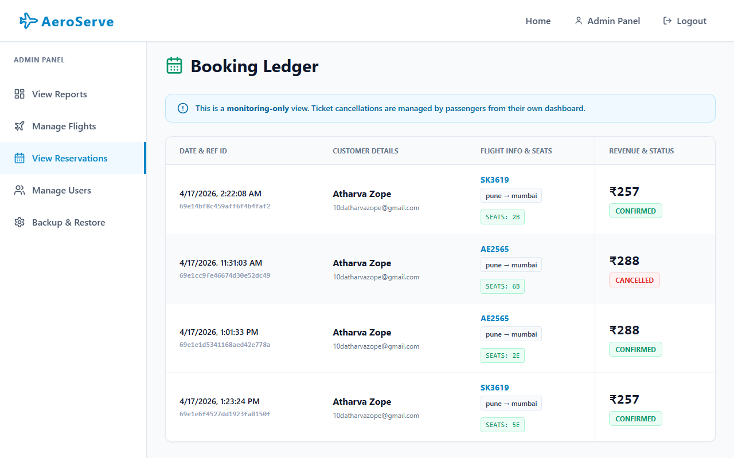
TC-015 | Admin Backup & Restore. | Generates a full JSON dump of the DB; allows uploading to restore collections. | As Expected | Pass | 